CIS31041-Practical for Data Mining

Reg no: SEU-IS-19-ICT-003

Title: Clustering Analysis and Classification using Python

Aim: Clustering the data set using K-Mean technique and Classification

Task: Working with K-Mean classification
Working with Classification

Exercises:
Question-01
- Import the suitable libraries
- Import the Bank.CSV file into Google colab notebook
- Make an array of dataset
- Create the Elbow chart
- Find the number of clusters
- Define the clusters for each record
- Concatenate the dataset and the cluster index
- Visualize the clusters
- Find the cluster centroid for each cluster
- Visualize the cluster centroids in the scatter plot

Question 02
- Import suitable libraries
- Upload the data set Bank.CSV
- Separate the data frame into two parts
- Delete the class variable in independent dataset
- Split the dataset into test and training set
- Find the prediction of the Using Decision tree
- Construct the confusion matrix

Exercises:
Question-01
- Import the suitable libraries
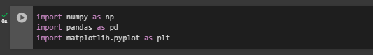

- Import the Bank.CSV file into Google colab notebook
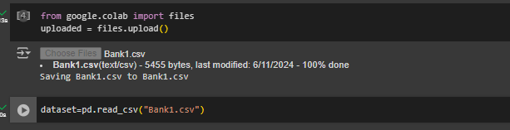

- Make an array of dataset
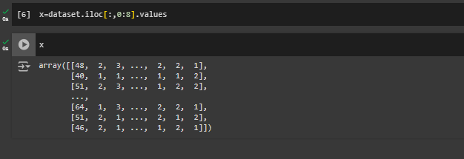

- Create the Elbow chart
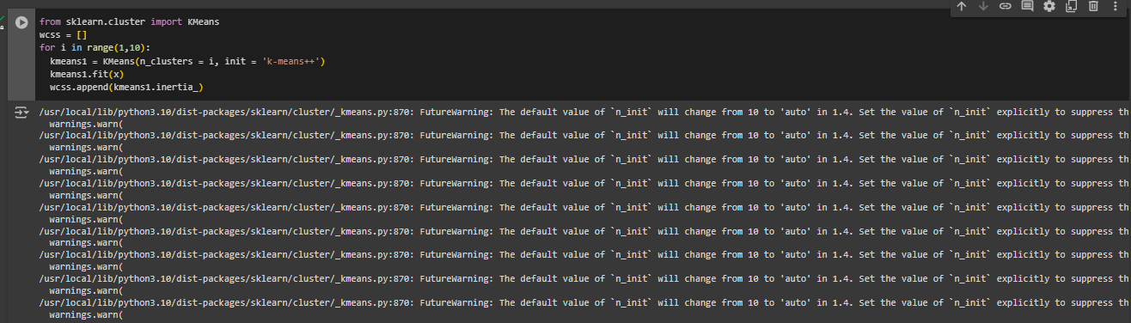

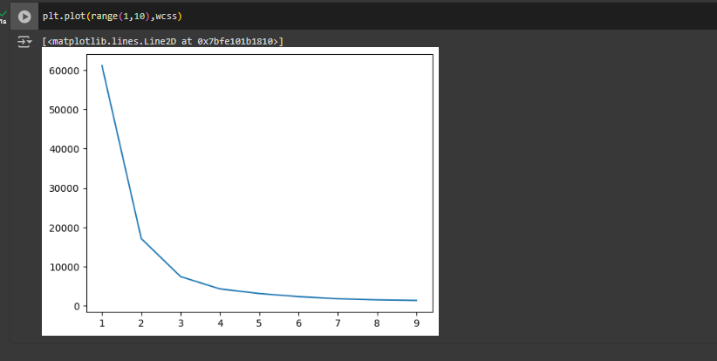

- Find the number of clusters

The elbow chart indicates that there are three clusters, since the first three have significant differences in value for each cluster, while the remaining clusters 4,5, 6 show relatively little variation in value for each cluster. in order for us to obtain
The first three values
Number of clusters are 3

- Define the clusters for each record
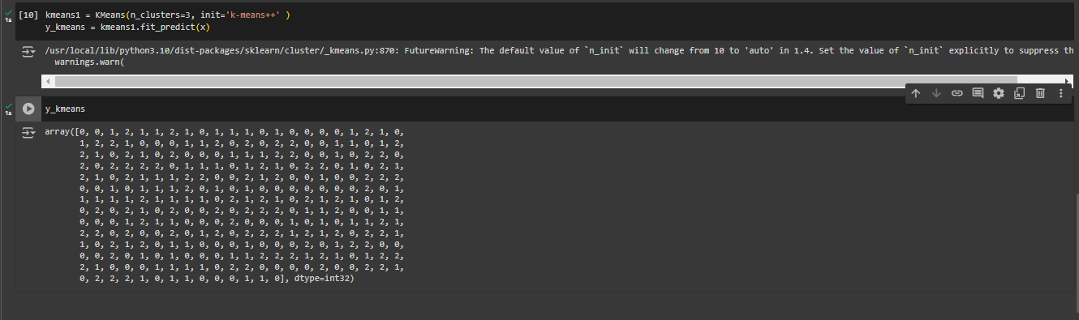

- Concatenate the dataset and the cluster index

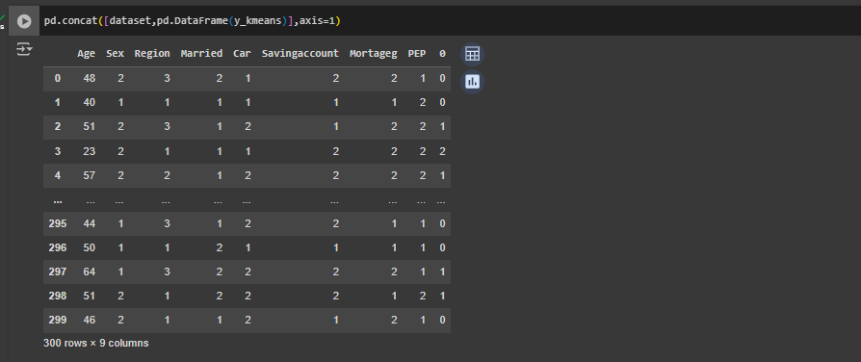

- Visualize the clusters
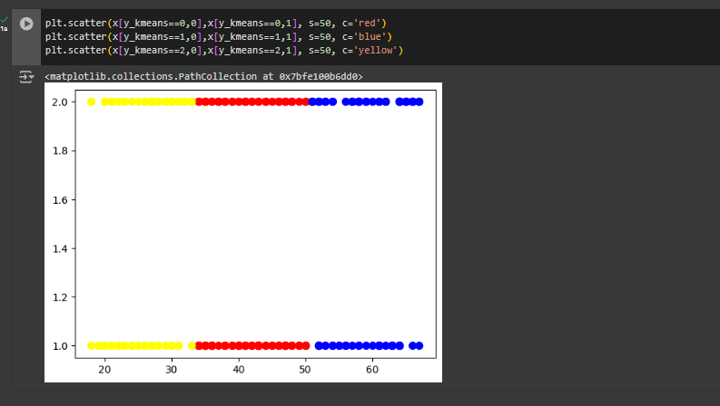

- Find the cluster centroid for each cluster
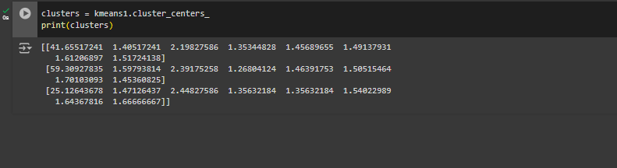

- Visualize the cluster centroids in the scatter plot
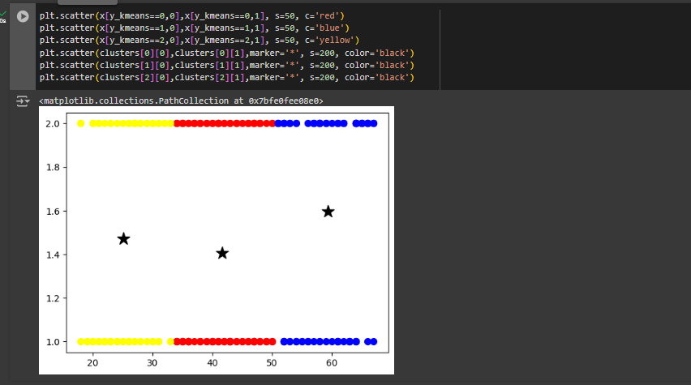

Question 02
- Import suitable libraries
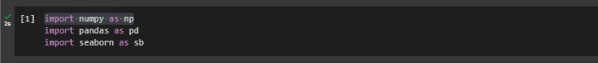

- Upload the data set Bank.CSV
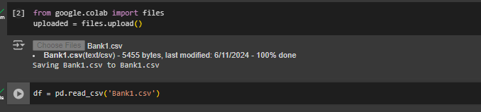

- Separate the data frame into two parts
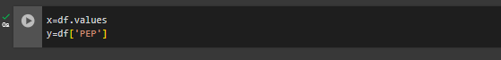

- Delete the class variable in independent dataset

- Split the dataset into test and training set

- Find the prediction of the Using Decision tree
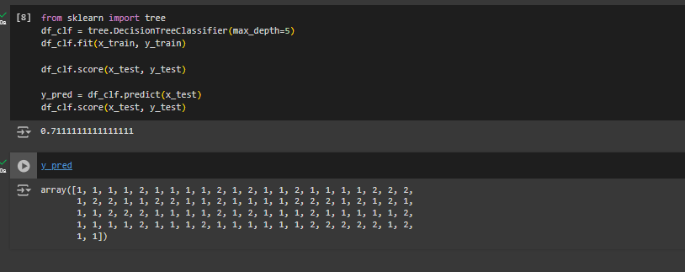

- Construct the confusion matrix
